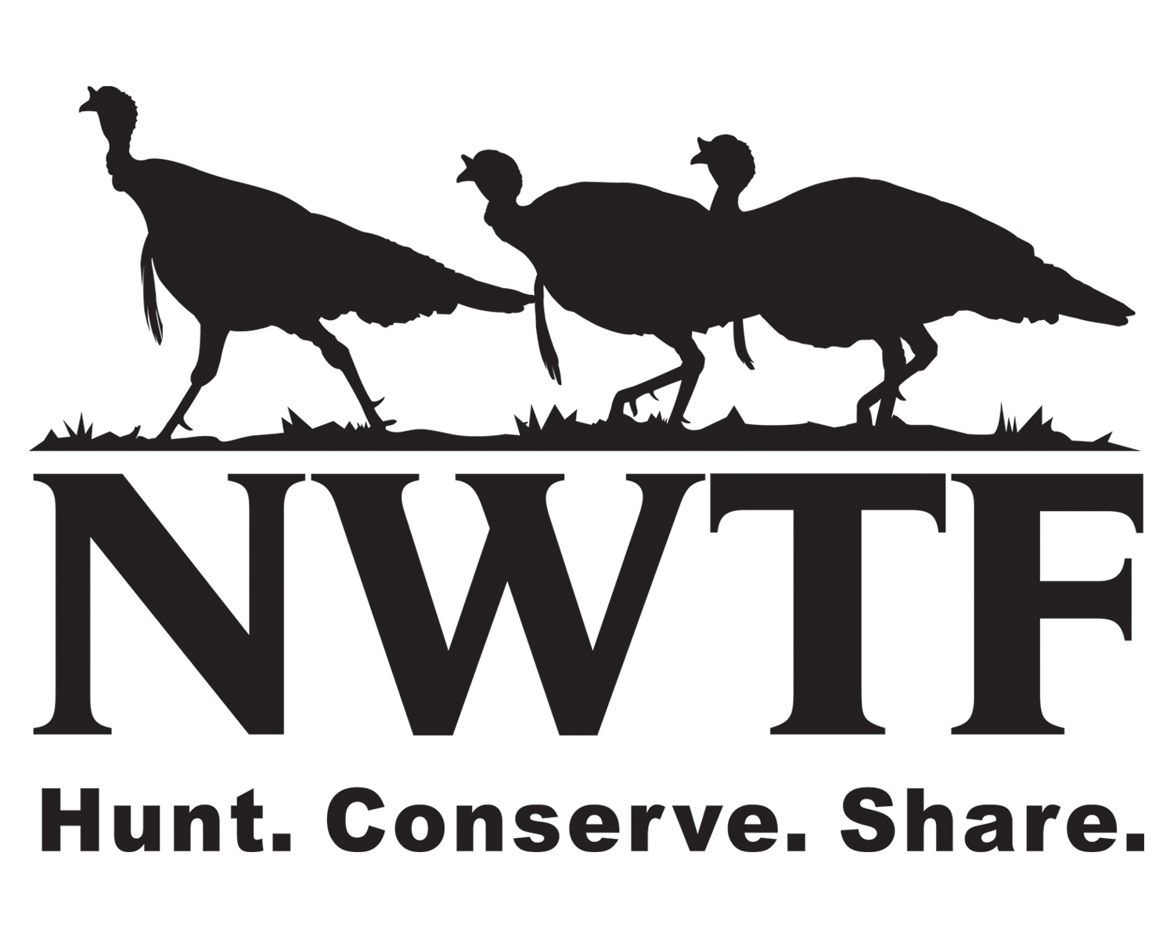
NWTF OUTREACH EVENT REGISTRATION FORM

All NWTF chapter events are covered by a blanket insurance policy IF they are registered with the national office at least 30 days
prior to the date of the event. To register, please complete the form below and submit to headquarters.

REGIONAL DIRECTOR:
CHAPTER NAME: |  |  |  |  |  |  |  |  |  |  |  |  |  |  |  |  |  |  |  |  |  |  | State:
EVENT TYPE: (Check all that apply)
 |  | JAKES Event |  |  |  |  |  | X-TREME JAKES Event |  |  |  |  |  |  |  |  |  |  |  |  |  |  |  | JAKES Hunt
Project Contact Person:
Contact Address:
City/State/Zip Code:
Contact Email Address:
Contact Phone Work Number:
EVENT INFORMATION:
Date of Event: |  |  |  |  |  |  |  |  |  |  | Check one: |  |  |  |  | First Time |  |  |  |  |  |  |  |  |  | Repeat
Event Name:
Event Location:
City/State/Zip Code:
Is this event location (check one): |  |  |  |  | Private |  |  |  |  |  |  | State Property |  |  |  |  |  |  |  | Forest Service Property
 |  |  |  |  | Military |  |  |  |  |  |  | Other Property? Please list specific location names
EVENT DESCRIPTION (Including activities planned and/or species hunted)

Are there any US Forest Service, USFWS, or state agency partners working with you on this event?
(If yes, please specify which ones.) |  |  |  | YES |  |  |  |  |  |  |  |  |  |  |  |  | NO
How many participants do you anticipate/can you accommodate at this event?
Will you be requesting Super Fund money for this event? |  |  |  |  |  |  |  |  |  |  |  |  | YES |  |  |  |  |  |  | NO
(If yes, please make sure you also submit the Super Fund request to your state chapter)

Mail, Fax, or Email completed form to:
NWTF Conservation Outreach Programs
PO Box 530, Edgefield, SC 29824
Fax: (803) 637-9180 Email: jplunkett@nwtf.net



NWTF Office Use Only: Rec’d by: |  | Date: | Revised: 11/05/09

